CS 255 System Design Document Template

UML Diagrams

UML Use Case Diagram
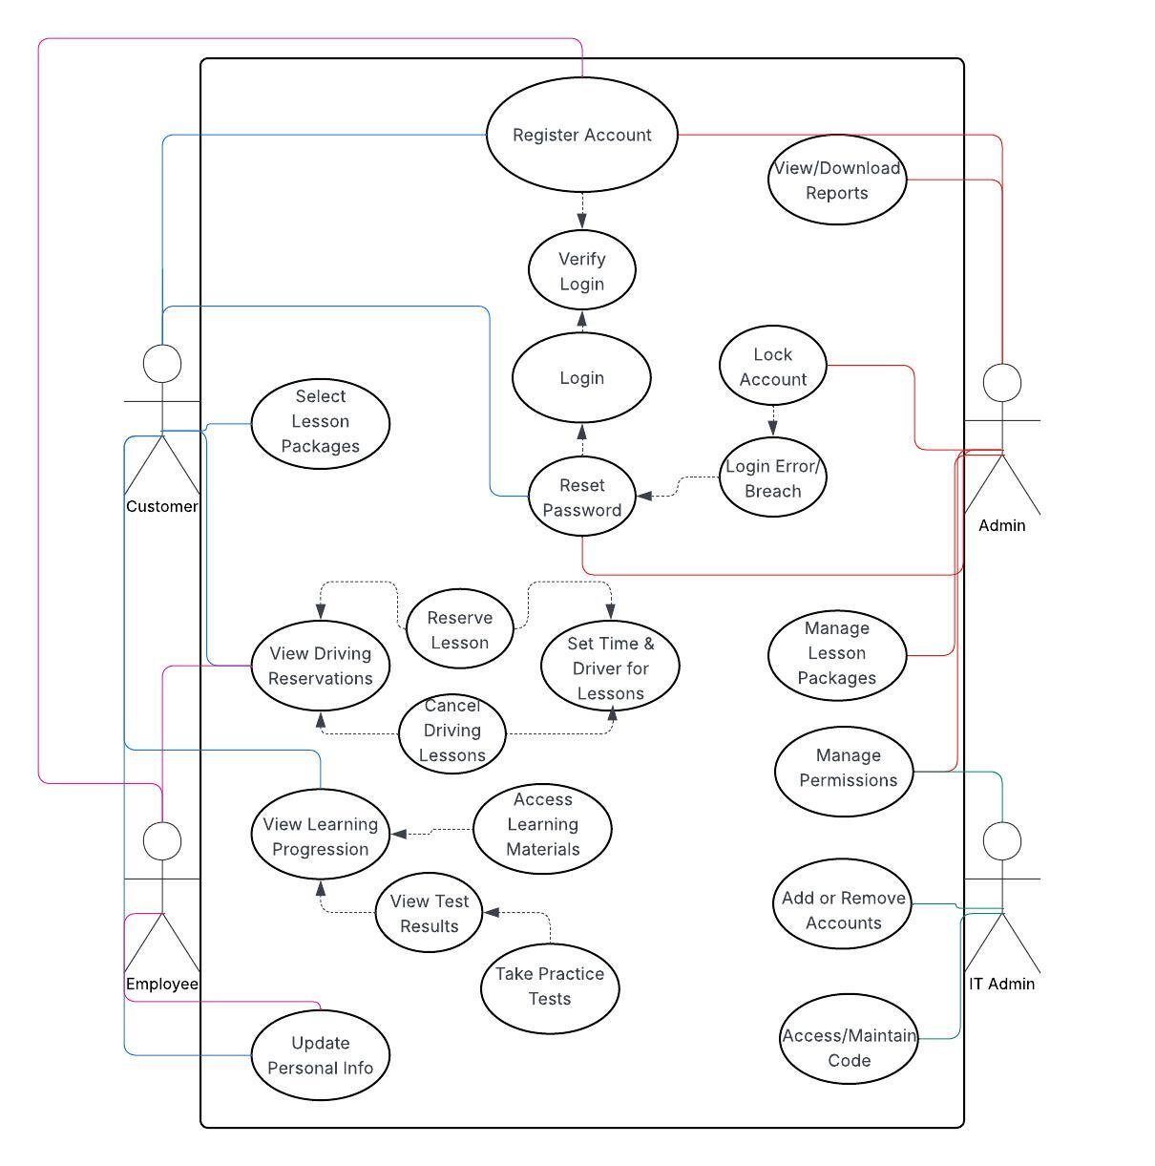

UML Activity Diagrams
Login/Account Registration
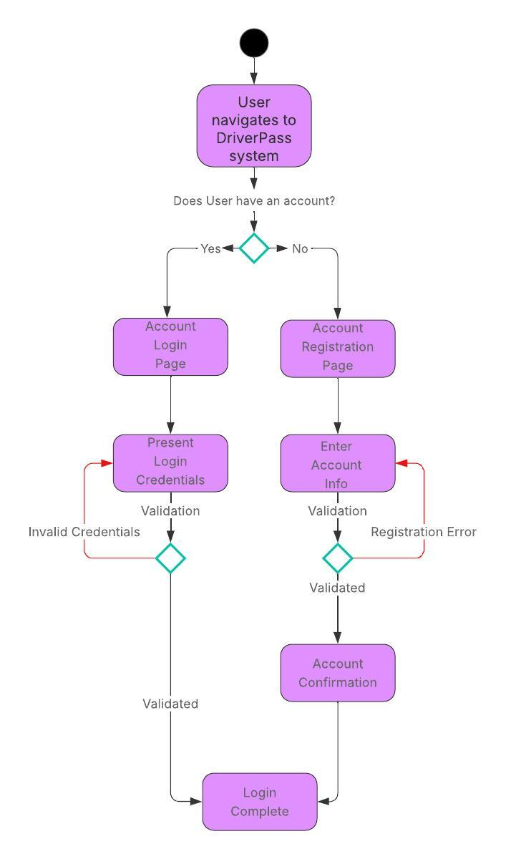
Disabling Packages
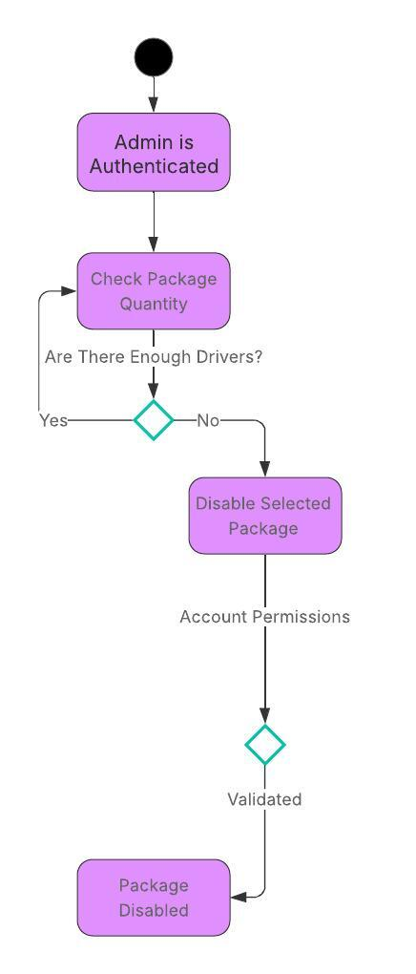

UML Sequence Diagram
Account Registration
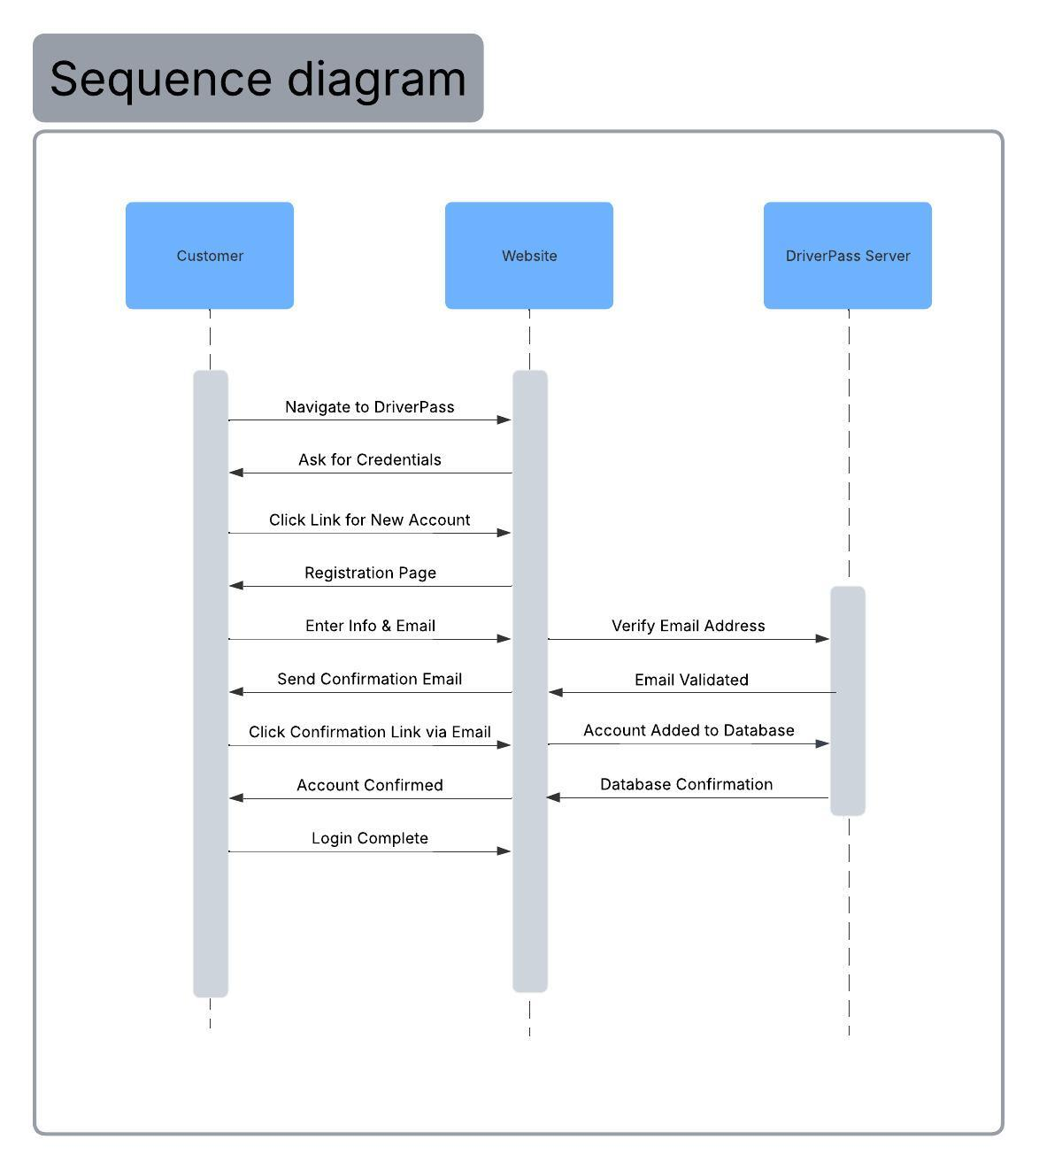

UML Class Diagram
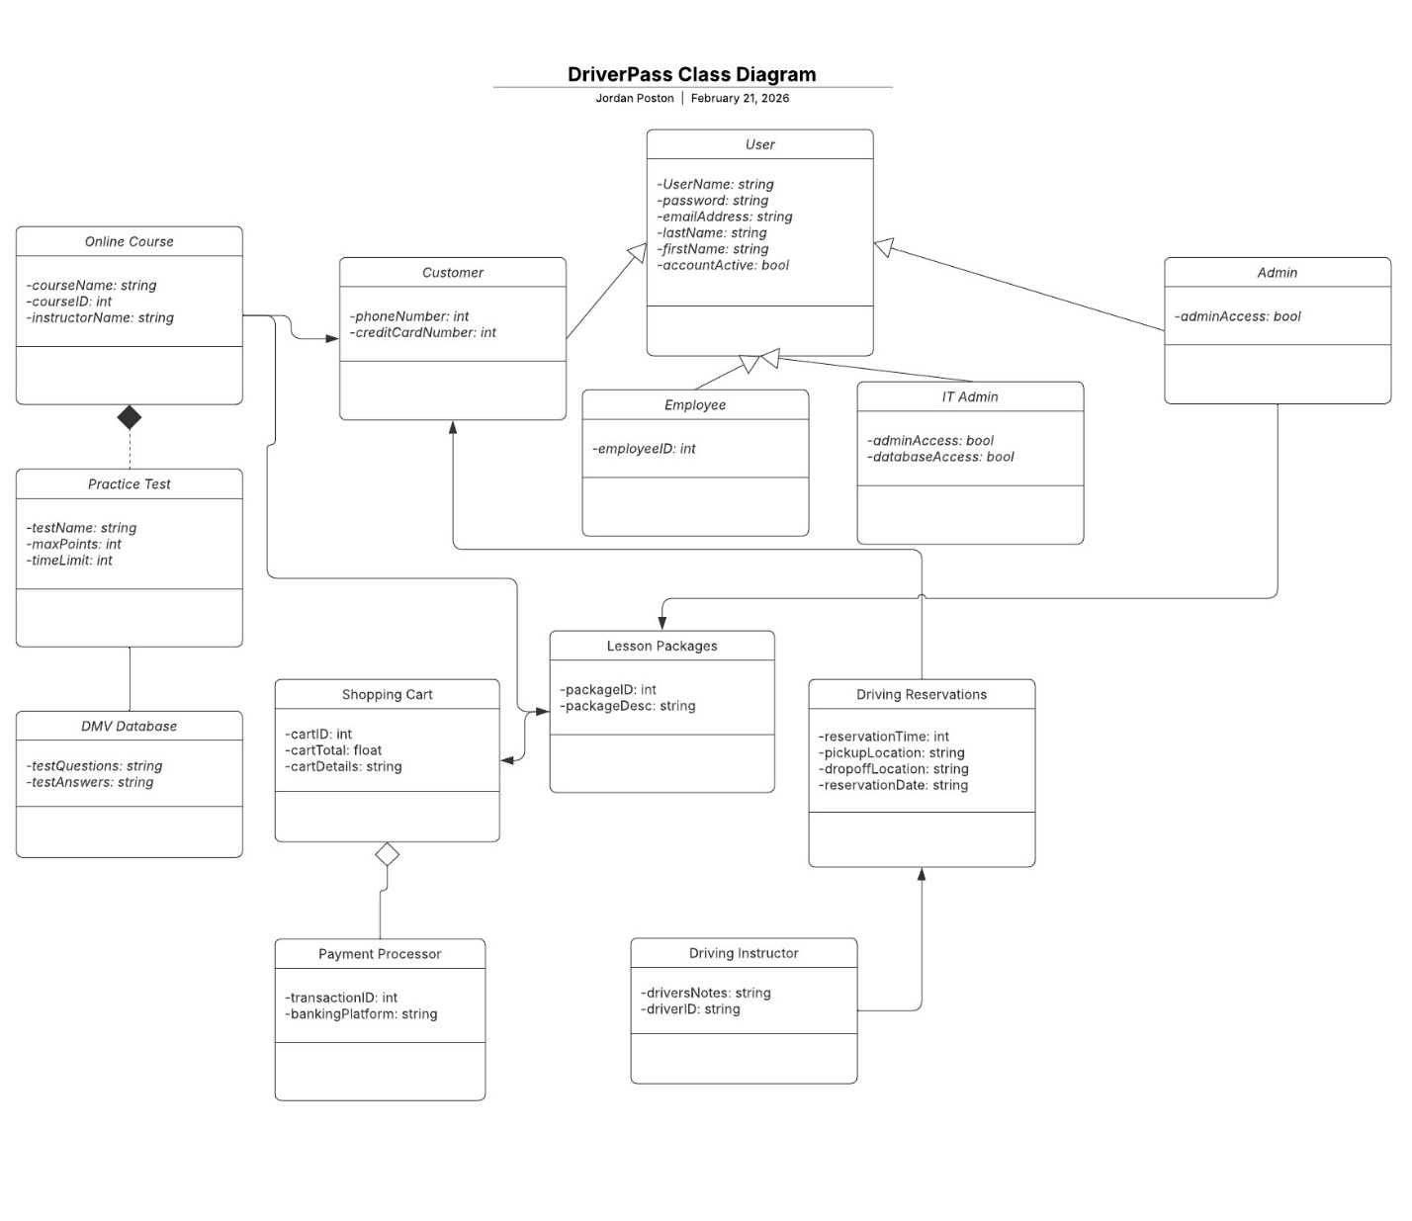

Technical Requirements
Hardware Requirements:
- Dedicated server for the DriverPass system
- Ample storage in cloud environment for database
- Reliable internet connection
- A desktop/laptop with reliable internet and compatible browser needed to access website
Software Requirements:
- Compatible and reliable OS
- Software for database with scheduled backups
- Cloud environment managed by a third party
- Security software and reliable firewall
Tools:
- Admin tools to monitor network traffic
- Programming software to make changes as needed

